Friday, July 9, 2021
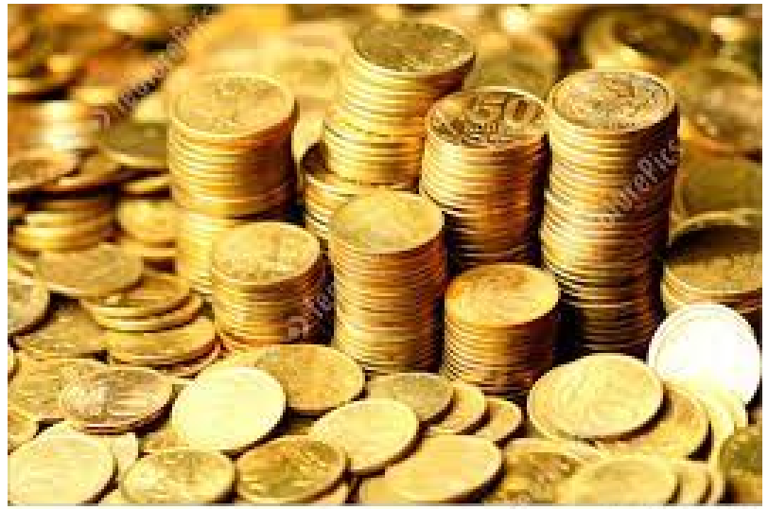
GATA: The Original Whistleblowers
No doubt most of you know all about the Gold Anti-Trust Action Committee, otherwise known as “GATA” founded in the late 1990’s by my two dear friends Bill Murphy and Chris Powell. I freely contribute to Bill’s website (lemetropolecafe.com) arguably the best place on the planet to get solid input from an army of free market proponents and it remains the premier site (and probably one of the last) to offer unbiased commentary on capital markets that either compliment or compete with the precious metals narrative.
The first time I with Bill Murphy on a one-on-one basis was in Toronto during the PDAC Conference in around 2006 and after a particularly gruelling day of meetings, we agreed to meet at Hy’s on Adelaide Street at the piano bar, after which we decided that since we both had early meetings, we would have a nightcap and retire to bed. Unfortunately for the two of us, since we were both former professional athletes (albeit briefly), our backgrounds in hockey (mine) and football (Bill’s) led us down a path of commonality in that very few men in the world of business have reached a level of achievement like we did. However, Bill actually made the “bigs” with the Boston Patriots in 1968 as a wide receiver while my only claim to fame was in junior and college and training camp tryout with the 1976-1977 Saint Louis Blues (after which my dreams of being an NHL-er took on the flight path of a WWII Messerschmidt spiralling down to earth with its tail on fire)…
Needless to say, what started as a “nightcap” was elongated by story after story and laugh after laugh as the walls of unfamiliarity came tumbling down. At the end of the night, as much as we regretted our incorrigible dalliance, we both became common souls, woven from the same cloth and committed to the honour of the good fight, one governed by the rules of the game and offended by those that would seek unfair advantage. In athletics, you have recourse; in the world of government control of capital markets, you have NO recourse.
Bill’s co-founding partner, Chris Powell, is another powerhouse of causational influence in the global gold narrative but I admire and revere Chris for what is arguably the most poignant and searing quote on the state of capital markets which he delivered over ten years ago when he wrote: “There are no free markets anymore; there are only interventions.” You must understand that this was a statement made back when everyone truly believed in the Larry Kudlow mantra of “God Bless Free Market Capitalism” rendering Chris’s quote virtually ineffectual when in reality, it was THE quote of the century and, I should add, has been proven completely true.
Between Bill Murphy and Chris Powell, they have delivered, on a scarily consistent basis, a two-decade-plus expose of the most destructive narrative in the history of global finance. Even worse, the mainstream financial media has done all in its power to silence GATA and gold and any relevance to the “canary in the coal mine” utility that guided investment managers for years. Bill was a featured speaker for years at many of the investment conferences, speaking to packed rooms and trying desperately (and in most cases vainly) to educate the masses as to the criminal enterprises that controlled the precious metals markets. Bill and Chris have been in front of congressional hearings and delivered undisputed evidence of criminal collusion and government condonement of the illegality of bullion bank intervention.
The reason I am writing about GATA tonight has no bearing whatsoever on the future direction of the price of gold; it does however have an enormous bearing on the future direction of the price of integrity. Had Bill and Chris opted to begin a discussion on the importance of pegging one’s retirement on following the Fed, they would have standing-room-only crowds and several million Twitter followers. Instead, they are not a mainstream media hot-point; they are an afterthought steeped in unattended brilliance. I have read every input to Lemetropolecafe.com since 2008 and have been shocked by the pervasive indifference to its content, which is superb (excluding present company contributions, of course). I urge all of you to subscribe to the website (http://www.lemetropolecafe.com) .
Alas, if you are truly frightened by the changes in the fabric of monetary management these days, then you have been immune to the design and impact of “behavioural finance”, so masterfully honed and sculpted by the spin machine that selects the actors that are trotted out as “Fed Governors” or “ECB representatives” or “Treasury Secretaries” who have zero clue as to the outcome of policy “experiments” that have been ongoing since 2001. It was GATA that started to question the odd behaviour in the gold and silver markets as early as 1999 and despite pervasive ridicule by CNBC and BNN and the WSJ, it was only twenty years later that RICO charges were levied against a few of the bullion banks. I wrote back then that until you had someone go to jail (other than a lowly margin clerk or desk trader), the status quo would remain in place and sure enough, here we are…nobody of importance is in jail and nobody CARES that they are NOT in jail. Worse still, the only time a crime is committed in broad daylight and no one goes to jail despite overwhelming evidence is if government grants a pre-trial pardon, falling under the category of not “innocent until proven guilty” but rather “innocent despite being proven guilty”.
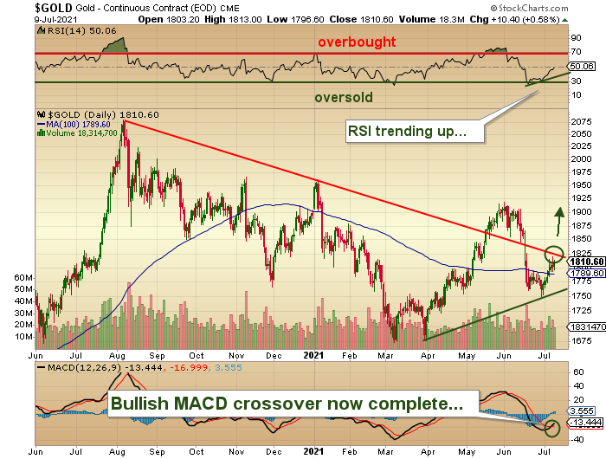
For those of you that think of me as a “gold bug”, I would ask that you re-think that. I first entered into a conversation with a gold bug back in 1978 at a conference at the old Royal York Hotel in Toronto. I was there as twenty-five year old attendee in a training program with a prestigious Canadian securities firm (McLeod Young & Weir) and after a discussion with one of their eminent economists whose prognostications were quoted weekly in the Globe and Mail’s “Report on Business” section (seen in multiple commuter train seats by multiple coffee-sipping, cigarette-smoking young “financial executives” in the 1970’s), I decided that I had better find out about this “hard asset thing” upon which every starving bond salesman was beginning to rely. This gentleman, who shook my hand with the ferocity of a wounded polar bear, proudly introduced himself as “Igor” but judging from his accent, which was unarguably “Rexdale” (a Canadian working-class suburb northwest of the city of Toronto), I determined that his real name was probably Greg Macdonald or Billy Smautz and that his working knowledge of the utility of gold and silver was synonymous with his working knowledge of female canines in heat (and possibly interchangeable). Nevertheless, it was his eyes that gave me the distinct impression that I was not in the Royal York but rather in a Revival Tent, somewhere in the deep south, complete with fainting women, crying men, and heavily-sweating preachers.
Gold bugs never sell gold. They only want us to believe that they are always and only buyers. However, when they get overleveraged and have to sell gold because it has been up for sixteen consecutive weeks and they were “parlaying” their equity for a move to USD $15,000 per ounce, the gold bug “rule” dictates that you never have to disclose a sale of your precious gold position if (and only if) you were forced out by the criminal collusion of the bullion bank behemoths. Which brings me to another annoyance: Why is it that every gold “guru” takes bows after major advances but issue zero apologies after crashes?
Back in June, committing a sacrilege within the gold bug community, I issued a “sell” for my subscribers and once they had a few days to act, I tweeted it out that we were shorting the overbought gold market at USD $1,909 not because we were expecting a return to $300 gold as in 1999, but simply and purely as a trading opportunity. What resulted was an eery silence during which I was criticized by the Twitterverse and by a few subscribers for “failing to see the big picture”. I responded with the remark that “on the roadsides of “big picture” believers are the bodybags of their disciples”.
Gold and silver, my friends, are going higher. All the armchair quarterbacks that offer opinions on stocks and bonds and crypto are operating on the premise that when the ultimate inflationary, Zimbabwe-esque lift-off occurs, they will always be able to pull up a website and see their wealth grow. I have a flash for you: If the power gets shut off and the banks go into receivership, those poor citizens will have nothing with which to barter. What? The power cord on your dead laptop? The carrying case for your USD $5,550 Apple Zinceron tablet? The golf cart you gave to your blind mother-in-law to get to the Community Bingo Hall?
You get my drift…
I am about to head north this week for my annual sojourn into the northern Georgian Bay wilds. The water level has dropped back to levels not seen in a few years so the bad news is that the big boats are unable to anchor in bays that were up last summer but the good news is that rocks that were invisible then are frighteningly visible now so the playing field of “Rocks versus Boater” has been somewhat “levelled” (with the operative word being “somewhat”)…
MJB
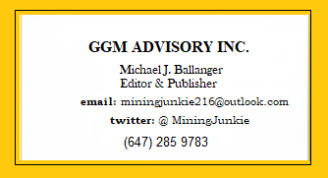
Disclaimer:
This letter makes no guarantee or warranty on the accuracy or completeness of the data provided. Nothing contained herein is intended or shall be deemed to be investment advice, implied or otherwise. This letter represents my views and replicates trades that I am making but nothing more than that. Always consult your registered advisor to assist you with your investments. I accept no liability for any loss arising from the use of the data contained on this letter. Options and junior mining stocks contain a high level of risk that may result in the loss of part or all invested capital and therefore are suitable for experienced and professional investors and traders only. One should be familiar with the risks involved in junior mining and options trading and we recommend consulting a financial adviser if you feel you do not understand the risks involved.

